|  | Learning rate | Dropout prob | Fc middle layer | Decay | Num Frozen | Num epochs | Validation Loss |
| --- | --- | --- | --- | --- | --- | --- | --- |
| 1 | 0.002 | 0.5 | 1024, 256 | 0.01 | 0 | 10 | 1.48 |
| 2 | 0.002 | 0.5 | 1024, 256 | 0.01 | 14 | 10 | 1.48 |
| 3 | 0.002 | 0.3 | 1024, 256 | 0.01 | 14 | 10 | 1.48 |
| 4 | 0.002 | 0.3 | 1024, 256 | 0.01 | 14 | 20 | 1.5 |
| 5 | 0.001 | 0.2 | 1024, 512 | 0.01 | 14 | 20 | 1.48 |
| 6 | 0.001 | 0.2 | 2048, 1024 | 0.01 | 14 | 20 | 1.48 |
| 7 | 0.001 | 0 | 2048, 2048 | 0.1 | 24 | 30 | 1.44 |
| 8 | 0.001 | 0.3 | 2048, 2048 | 0.1 | 24 | 30 | 1.34 |
| 9 | 0.001 | 0.5 | 2048, 2048 | 0.1 | 24 | 30 | 1.35 |
| 10 | 0.002 | 0.5 | 2048, 2048 | 0.1 | 24 | 30 | 1.47 |
| FINAL CHOICE | 0.001 | 0.25 | 2048, 2048 | 0.1 | 24 | 50 | 1.2  Test loss = 0.99 |

1

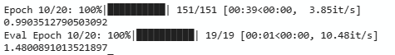

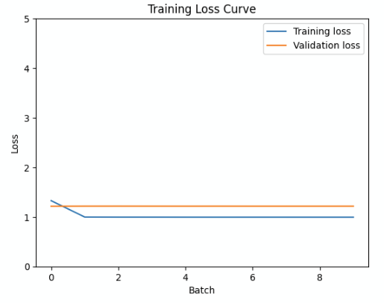

2

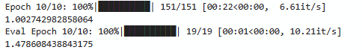

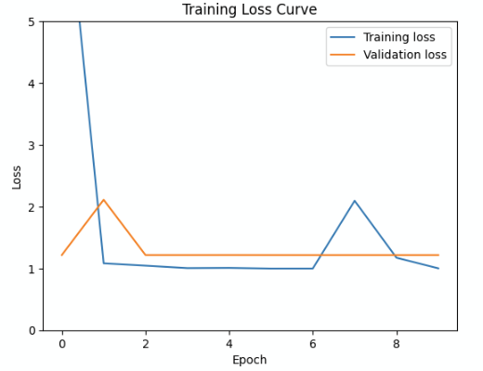

3



4

(3 but after more epochs)

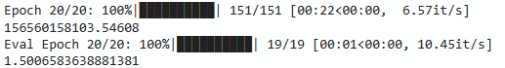

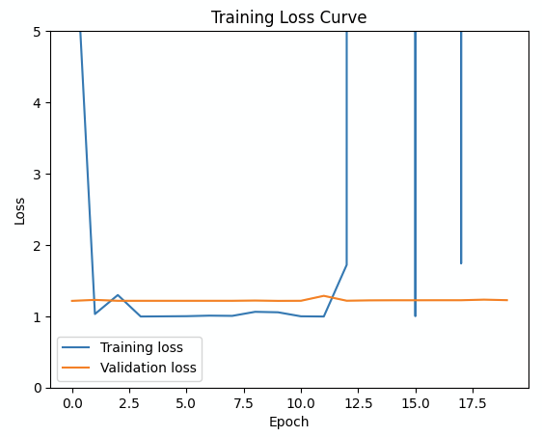

5

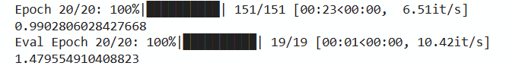

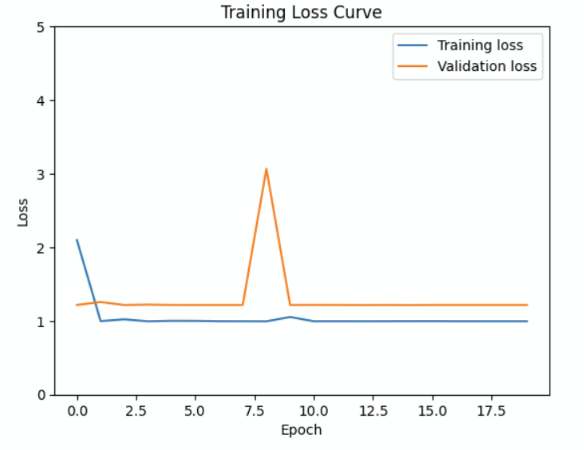

6

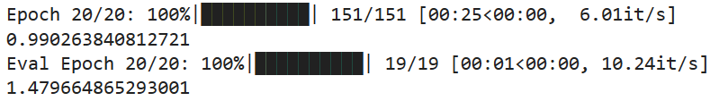

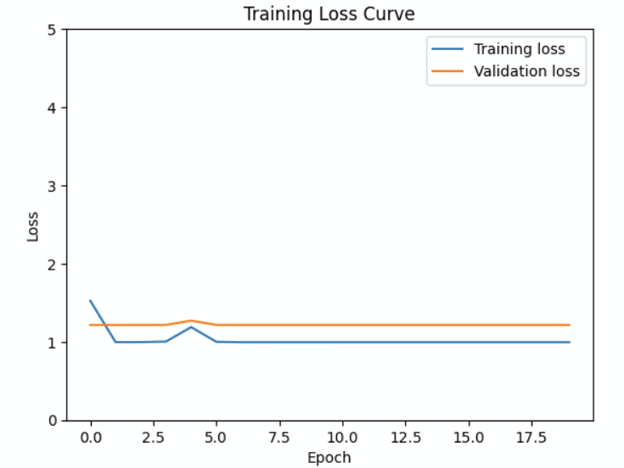

7

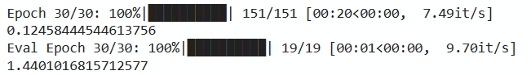

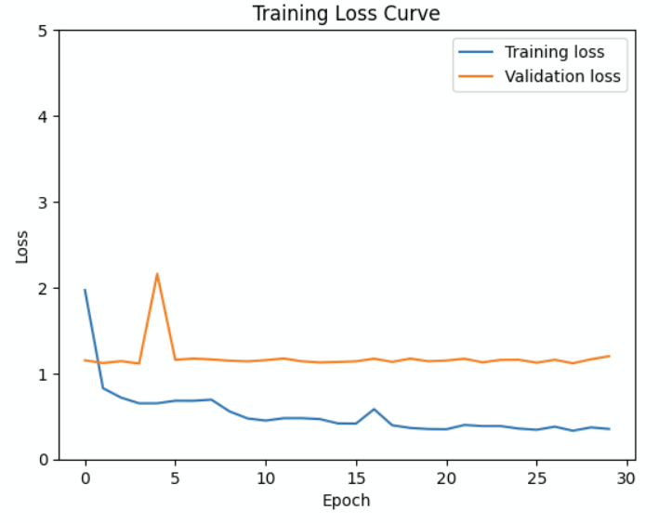

8

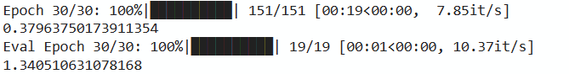

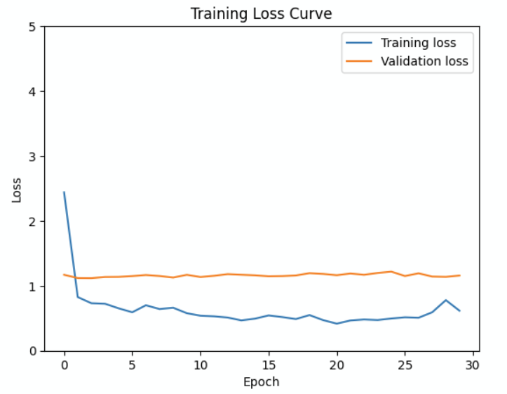

9

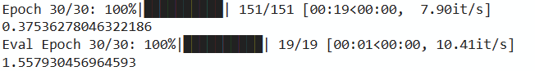

Lowest at:

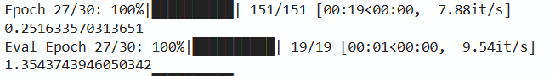

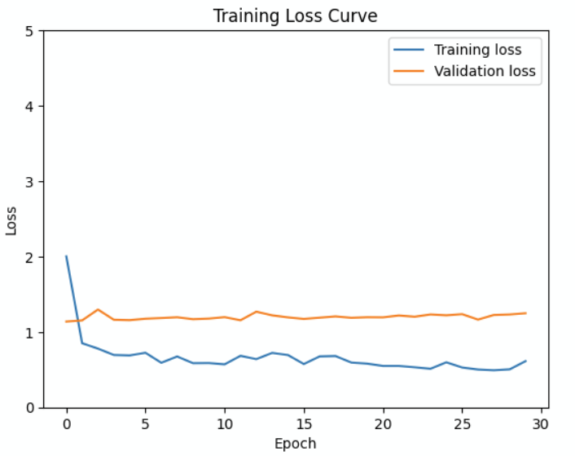

10

